Keep Title Less than 120 Characters

First Author¹, Second Author², Third Author³

¹Department of Architecture, University of Jos, Nigeria
author1@email.com

²The Nigerian Institute of Architects, Abuja, Nigeria,
author2@email.com

³Department of Architecture, Covenant University, Ota, Nigeria
author1@email.com

Abstract: These instructions provide you guidelines for preparing papers for Journal of the Nigerian Institute of Architects (NIAJ). Use this document as a template and as an instruction set. Please submit your manuscript by NIAJ Online Submission Module.

Keywords: about four key words separated by commas

Introduction

When you submit your paper print it in two-column format, including figures and tables. In addition, designate one author as the “corresponding author”. This is the author to whom proofs of the paper will be sent. Proofs are sent to the corresponding author only

Page Size and Layout

Set your page as A4, width 210, height 297 and margins as follows:

- Left Margin 17.8 mm (0.67")
- Right Margin 14.3 mm (0.56)
- Top Margin – 17.8 mm (0.7")
- Bottom Margin – 17.8 mm (0.7")

You should use Arial of size 10 for all fonts in the paper. Format the page as two columns:

- Column Width 86.8 mm (3.42")
- Column Height – 271.4 mm (10.69")
- Space/Gap between Columns - 5.0 mm (0.2").

Title, Authors, Body Paragraphs, Sections Headings and References

Title and authors

The title of the paper is centered 17.8 mm (0.67") below the top of the page in 24-point font. Right below the title (separated by single line spacing) are the names of the authors. The font size for the authors is 11pt. Author affiliations shall be in 9 pt.

Body paragraphs

The main text for your paragraphs should be 10pt font. All body paragraphs (except the beginning of a section/sub-section) should have the first line indented about 3.6 mm (0.14").

Figures and Tables

Place illustrations (figures, tables, drawings, and photographs) throughout the paper at the places where they are first discussed in the text, rather than at the end of the paper. Number illustrations sequentially (but number tables separately). Place the illustration numbers and caption under the illustration in 10 pt font. Do not allow illustrations to extend into the margins or the gap between columns (except 2-column illustrations may cross the gap). If your figure has two parts, include the labels “(a)” and “(b)”.

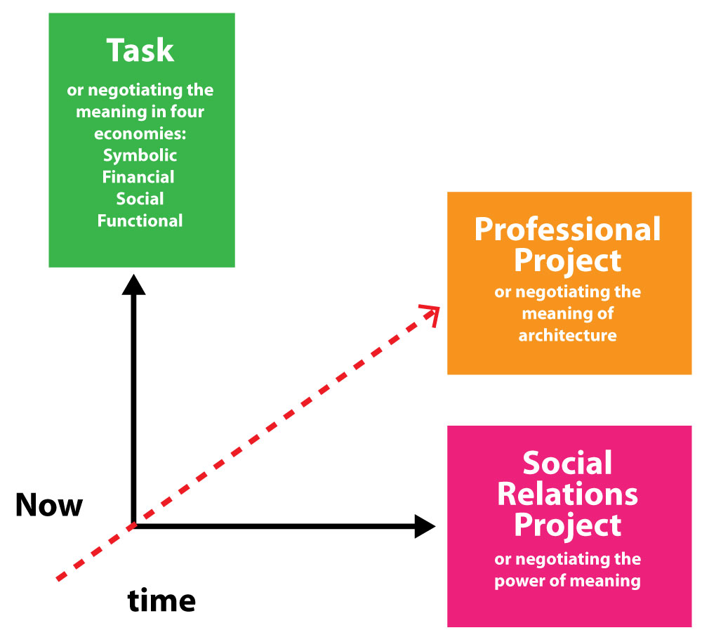
Figure 1: An Operational Model of Architecture Practice
Source:

Tables

Place table titles above the tables.
Table 1: Margin specifications
Margin | A4 Paper | US Letter Paper
Left | 18.5 mm | 14.5 mm (0.58 in)
Right | 18mm | 13 mm (0.51 in)

Sections headings

Section headings come in several varieties:
- first level headings: 1. Heading 1
- second level: 1.2. Heading 2
- third level: 1.2.3 Heading 3

References

In referencing this paper, use APA 7th edition (2020). Please note that the references at the end of this document are in the preferred referencing style. Please ensure that the provided references are complete with all the details and also cited within the manuscript.

Equations

If you are using Word, use either the Microsoft Equation Editor or the MathType add-on (http://www.mathtype.com) for equations in your paper (Insert | Object | Create New | Microsoft Equation or MathType Equation). “Float over text” should not be selected.

Number equations consecutively with equation numbers in parentheses flush with the right margin, as in (1). First use the equation editor to create the equation. Then select the “Equation” markup style. Press the tab key and write the equation number in parentheses.

$E=\sum_{p=1}^{P}{}\sum_{k=1}^{K}{(δ_{\text{pk}}^{o})^{2}}$ (1)

Other recommendations

Equalize the length of your columns on the last page. Using Word, proceed by Insert/Break/Continuous.

Your paper will be subject to double blind peer review. If your paper is accepted for publication, analyse and understand all the provided review comments thoroughly. Now make the required amendments in your paper. After submission, NIAJ will send you reviewers comment within 10-15 days of submission. You are expected to send us the updated paper within a week for publishing.

References

Mintzberg, H. (1991). The effective organization: Forces and forms, 1 (1), 22-28. Retrieved from http://www.sloanreview.mit.edu-winter-1991.html.

National Council of Architectural Boards (NCARB). (2013). China Random Fact Sheet.
Retrieved from http://www.ncarb.org/en/News-and-Events/News/1999/07-China-Random-Fact-Sheet.aspx.

Navarro-Astor, E. and Caven, V. (2014). Architects in Spain: A profession under risk. in Procs 28th Annual ARCOM Conference, ed Smith, Edinburgh: Association of Researchers in Construction Management, 578.

Nigerian Institute of Architects (NIA). (2017, November). Annual Report 2017. Presented at 57th Biennial General Assembly and conference (BGM 2017), Abuja.

Ogunrotifa, B. (2009). Federal Civil Service Reform in Nigeria: The Case of Democratic Centralism. Urban Studies, (12): 2537-2554.

Author Profile

<Author Photo>
Bisi Eze Haruna received the B.S. and M.S. degrees in Architecture from University of Jos in 1997 and 1999, respectively. He is currently a lecturer in the Department of Architecture University of Jos where teaches Sustainable Architecture

